# [LAW & ORDER: SPECIAL VICTIMS UNIT: Octavio Pisano Previews Velasco’s Reunion with Chilly](https://www.givememyremote.com/remote/2023/04/25/law-and-order-svu-velasco-chilly-octavio-pisano-interview/)

April 25, 2023 by [Marisa Roffman](https://www.givememyremote.com/remote/author/marisa/)

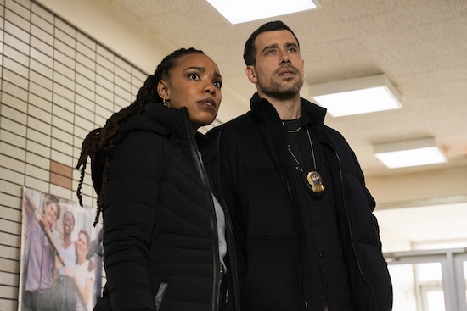

***LAW & ORDER: SPECIAL VICTIMS UNIT — “Bend the Law” Episode 24019 — Pictured: (l-r) Jasmine Batchelor as Officer Tonie Churlish, Octavio Pisano as Det. Joe Velasco — (Photo by: Ralph Bavaro/NBC)***

LAW & ORDER: SPECIAL VICTIMS UNIT’s Velasco ([Octavio Pisano](https://www.givememyremote.com/remote/2022/07/18/svu-octavio-pisano-interview/)) has had an extra burden on his shoulder in recent months, as Benson ([Mariska Hargitay](https://www.givememyremote.com/remote/2023/02/21/svu-king-of-the-moon-bts-photos-mariska-hargitay-directing/)) assigned him an important task: Track down his friend, Chilly (Joseph Castillo-Midyett), [who killed a couple of people—a couple of decades ago—to protect Velasco from the cartel](https://www.givememyremote.com/remote/2023/02/23/svu-did-velasco-kill-someone/).

“He’s hoping that it kind of washes away, with all the things that are coming up [for the squad],” Pisano tells [Give Me My Remote](https://www.givememyremote.com/remote/). “I think he’s kind of hoping that Benson forgets about it—until she brings it up.”

When they get a potential lead on Chilly’s location—out of state—Benson sends Velasco to look into it in [“Bend the Law”](https://www.givememyremote.com/remote/2023/03/31/law-and-order-organized-crime-bernie-return-ellen-burstyn-karen-david/) (airing Thursday, April 27)…with Churlish (Jasmine Batchelor), whose illegal recording of Velasco’s conversation with a suspect kickstarted the entire investigation.

“After what happened previously with Churlish, I think Velasco learned a lot about her,” Pisano says. “And he learned to keep his emotions away from his relationship with her, because he understands where she’s coming from. And we got that from how he explained to Muncy [who had been holding more of a grudge about the recording than Velasco was] and he gave her perspective on Churlish. But, obviously, he knows exactly why Benson is sending Churlish, and he feels the pressure of her accountability.”

As Velasco and Churlish work the case together, “he’s becoming a little more transparent with his conflict and everything, especially since they’re spending all this time together on the road,” Pisano previews. “And, ultimately, I think he does want to do the right thing. It’s just that he’s conflicted with knowing what the right thing *is*.”

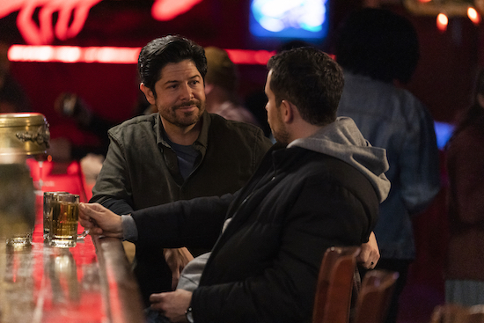

***LAW & ORDER: SPECIAL VICTIMS UNIT — “Bend the Law” Episode 24019 — Pictured: Joseph Castillo-Midyett as Anthony “Chilly” Suarez — (Photo by: Ralph Bavaro/NBC)***

When Velasco and Chilly reunite, the detective isn’t quite sure what to expect from his former friend.

“The question [Velasco]’s dealing with is [that] he understands change is inevitable, in the sense that he changed himself,” Pisano notes. “He knows himself now, he knows where he stands. He might feel differently about what’s right and wrong when it comes to the law, and when it comes to humanity, basically, but I think he just wants to know if Chilly’s in the same position as he is—if he learned the same lessons, if he grew out of that.”

Looking ahead, with the season rapidly coming to a close, Pisano has been busy filming the upcoming LAW & ORDER: SPECIAL VICTIMS UNIT and ORGANIZED CRIME crossover.

“I’m paired up with [Detective Reyes [played by Rick Gonzalez] from ORGANIZED CRIME](https://www.givememyremote.com/remote/2022/10/27/law-and-order-organized-crime-reyes-brothers-rick-gonzalez-interview/),” he previews. “They have very similar modes of operating and backstories and that was really cool to play.”